# Got Tasty

## Game flow chart

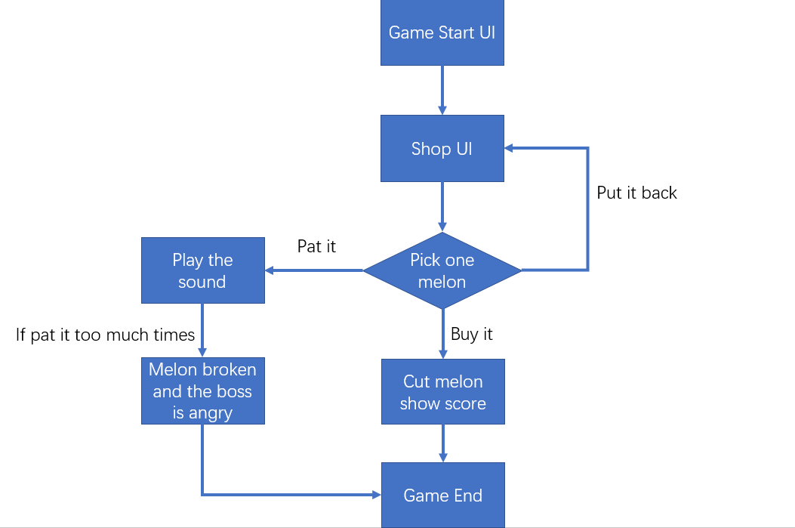

## Game UI

1. **Start UI**

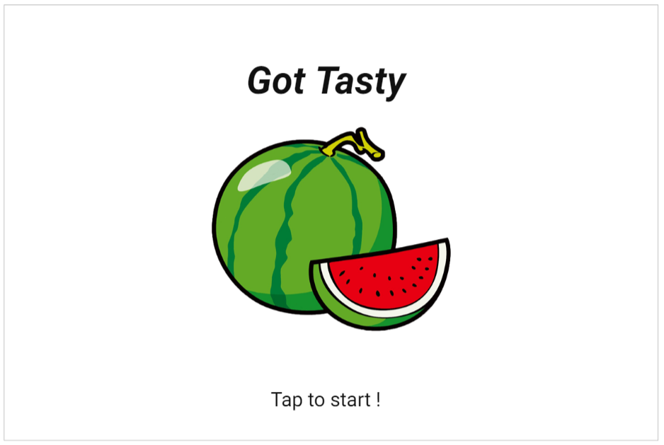

1. **Shop UI**

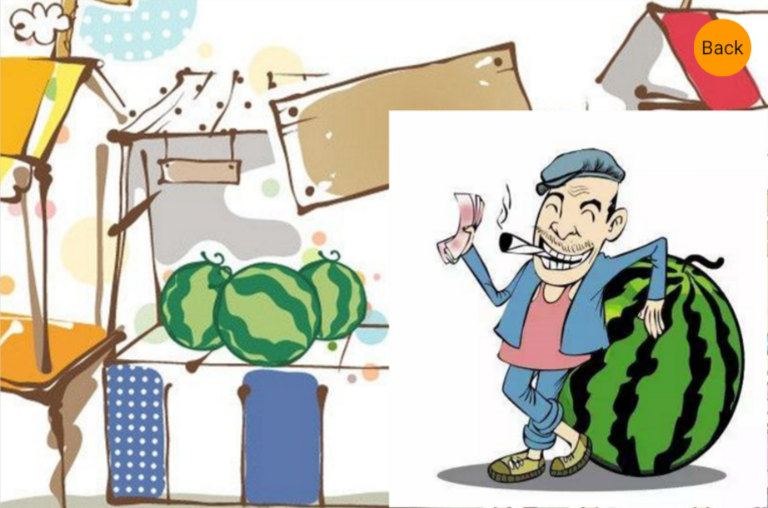

1. **When you pick a melon**

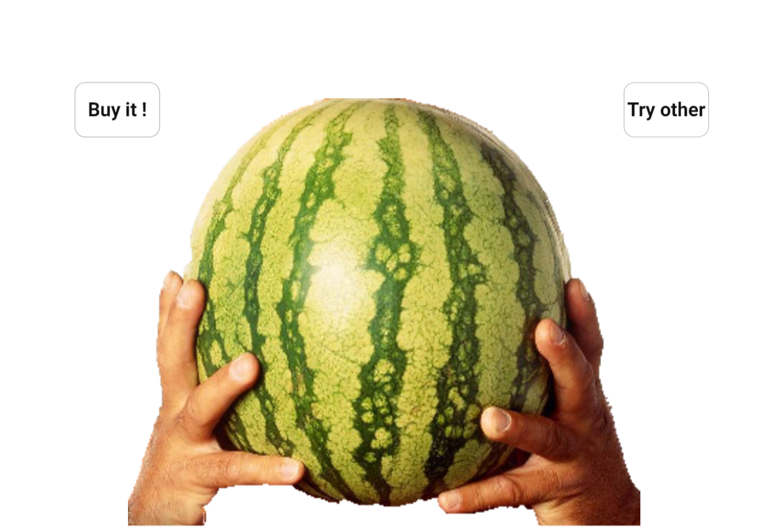

1. **When you buy a melon**

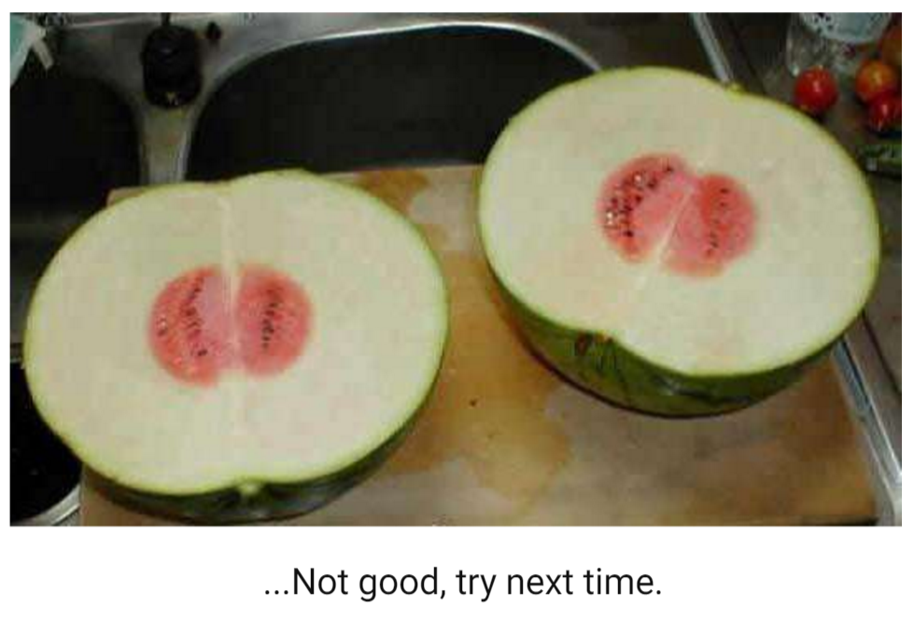

1. **When you break a melon**

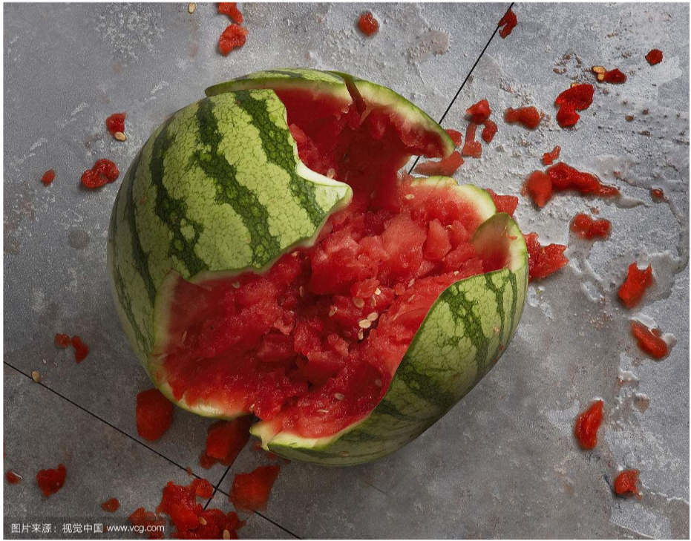

And need another picture is the boss is very angry.

Prototype:

<https://modao.cc/app/0kMEfUUgLGBrjU1ODxSUKZV4rW8bnsL#screen=s1DD6B1ECB71527005183550>